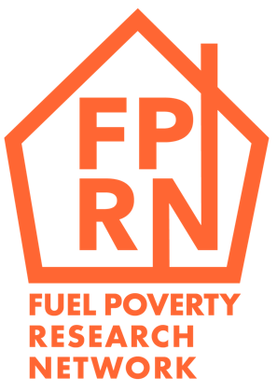 | Equality Monitoring Form
 | November 2021

Please note that all the information in this form will be kept confidential. Once collected, we keep the data separate from personal information so it is anonymous. You do not have to answer all or any of the questions on this form.

Please simple indicate the relevant answers with an ‘X’.

What is your gender?
Male
Female
Prefer to self-describe ____________
Prefer not to say

What is your date of birth?
DD/MM/YY

What is your ethnic background?

Asian
- Bangladeshi
- Chinese
- Indian
- Pakistani
- Other

Black/African/Caribbean
- African
- Caribbean
- Other

Mixed/multiple ethnic groups
- Asian and white
- Black African and white
- Black Caribbean and white
Other groups
- White (please specify)
- Other ethnic group
- Arab
- Gypsy or Traveller
- Other

If any other ethnic background, please state here: _______________

Prefer not to say

Do you consider yourself to have disability?
Yes
No
Prefer not to say

Do you have significant caring responsibilities?
Yes
No
Prefer not to say

Thank you for answering these equality monitoring questions. Please email your completed form to: naomi@fuelpovertyresearch.net

